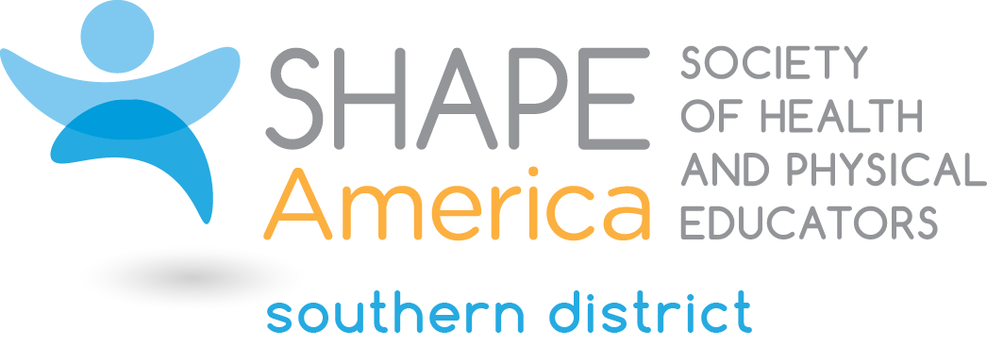
2019 Candidate for the Office of President-Elect

Hollie M. Newnam, Ph.D.
Executive Director
SHAPE Florida
Port Orange, FL

Hollie Newnam holds a Ph.D. in Physical Education from Florida State University, an M.S. in Educational Leadership from Nova University and a B.A. in Physical Education from the University of Central Florida. She taught at the high school and university levels for 23 years, served as an Assistant Principal and Principal for 10 years and is currently the Executive Director of SHAPE Florida.

Some of Hollie’s professional leadership and service at the state level include President of FAHPERDS two terms (now SHAPE FL), Chair of the Advocacy Strategy Panel and 18 years as convention program director. She served Southern District as the Physical Education Division Vice President, Membership Committee, Chair of the Nominations Committee and various other standing committees. Hollie co-chaired the local arrangements committee for the 2009 AAHPERD National Convention in Tampa and she is the current co-chair of the LAC for the upcoming SHAPE America convention in 2019. Hollie is a past recipient of the 2017 Southern District Honor Award, 2007 FAHPERD’s Peter Everett Honor Award and numerous other professional recognitions.

What leadership qualities will you bring to the Southern District Leadership Council?

PASSION: Hollie is passionate about our profession and has advocated for educating our youth, school communities, and legislators to embrace healthy active lifestyles. Her passion has lead her to school board meetings, the state capitol in Tallahassee to testify before committees as well as meetings with Congress members in Washington DC.
BUILDING RELATIONSHIPS: Continuing the Future Professional Leadership Development Conference and the Professional LDC are key to maintaining Southern District’s relationships within the states as well as continuing to provide a venue to provide professional development opportunities for our members. Hollie believes that moving forward as a team will allow us to continue our rich Southern District traditions and increase active membership.

